Le imposte sui redditi delle persone fisiche in Europa
Venerdì 29 ottobre 2021
14.30 – 16.20
in
Quale riforma tributaria?
Riflessioni e proposte dell’AIPSDT su IRPEF e giustizia tributaria

– Bari 29-30 ottobre 2021 –

Convegno annuale dell’Associazione Italiana dei Professori e degli Studiosi di Diritto Tributario (AIPSDT)

Table of Contents
Austria 1
Individual Income Taxation 1
1. Structure 2
2. Taxable unit 3
3. Rates 4
4. Income from capital 5
5. Alternative and substitutive regimes 7
France 8
Individual Income Taxation 8
1. Structure 9
2. Taxable unit 11
3. Rates 18
4. Income from capital 20
5. Alternative and substitutive regimes 23
Germany 24
Individual Income Taxation 24
1. Structure 25
2. Taxable unit 25
3. Rates 26
4. Income from capital 26
5. Alternative and substitutive regimes 26
Spain 28
Individual Income Taxation 28
1. Structure 29
2. Taxable unit 30
3. Rates 30
4. Income from capital 33
5. Alternative and substitutive regimes 34
UK 35
Individual Income Taxation 35
1. Structure 36
2. Taxable unit 36
3. Rates 36
4. Income from capital 37
5. Alternative and substitutive regimes 38

Austria

Individual Income Taxation
Presentation by
Prof. dr Georg Kofler, WU University of Vienna
georg.kofler@wu.ac.at

Structure
Total Amount of Income
Business Income  (tax accounting, indefinite loss carry- forward) |  |  |  |  |  | Non-Business Income  (cash flow, no loss carry-forward)
Agriculture and Forestry |  | Self- Employment |  | Commercial Operations |  | Employment |  | Capital Assets |  | Rentals and Leasing |  | Other Income
Lump-sum taxation |  | Profit allowance |  | Profit allowance |  | Wage tax, reduced taxation of 13th and 14th salary |  | Rate: 25%/27,5%,  final withholding tax |  | — |  | Capital gains from immovable property (27,5%),  final withholding tax
Total amount of income ./. Special expenses ./. Extraordinary burdens ./. Tax allowances = Income

Formally
Synthetic
structure

But
numerous
schedular
features

Taxable unit
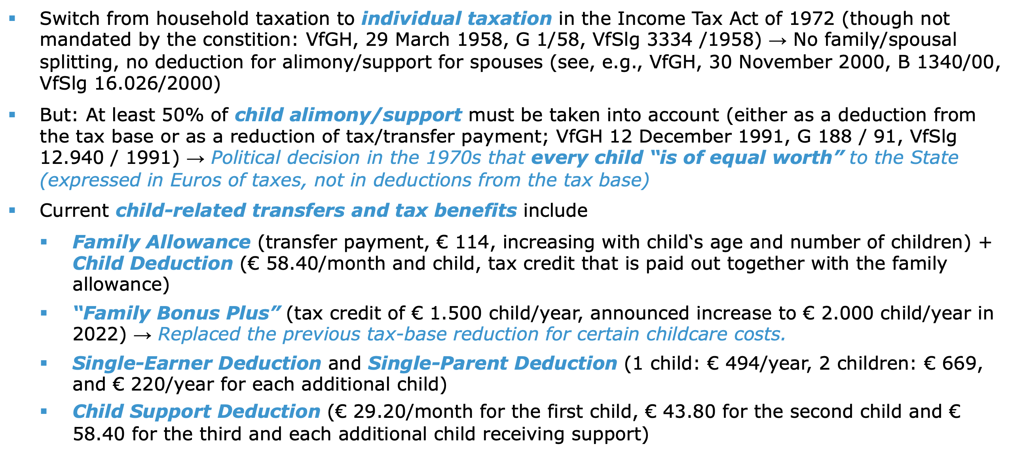

Rates
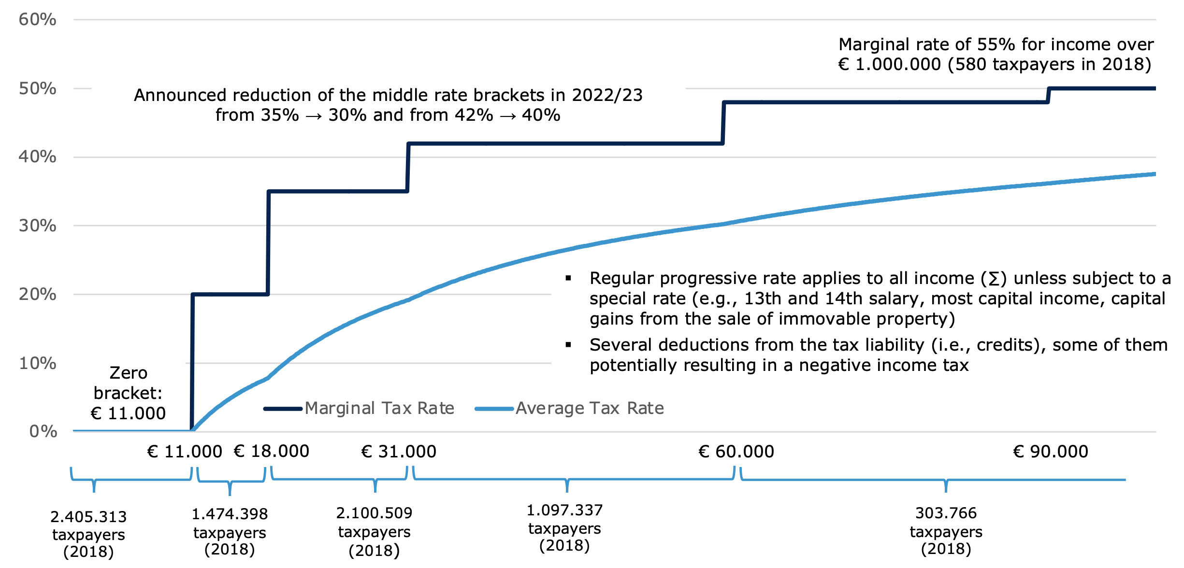

Income from capital
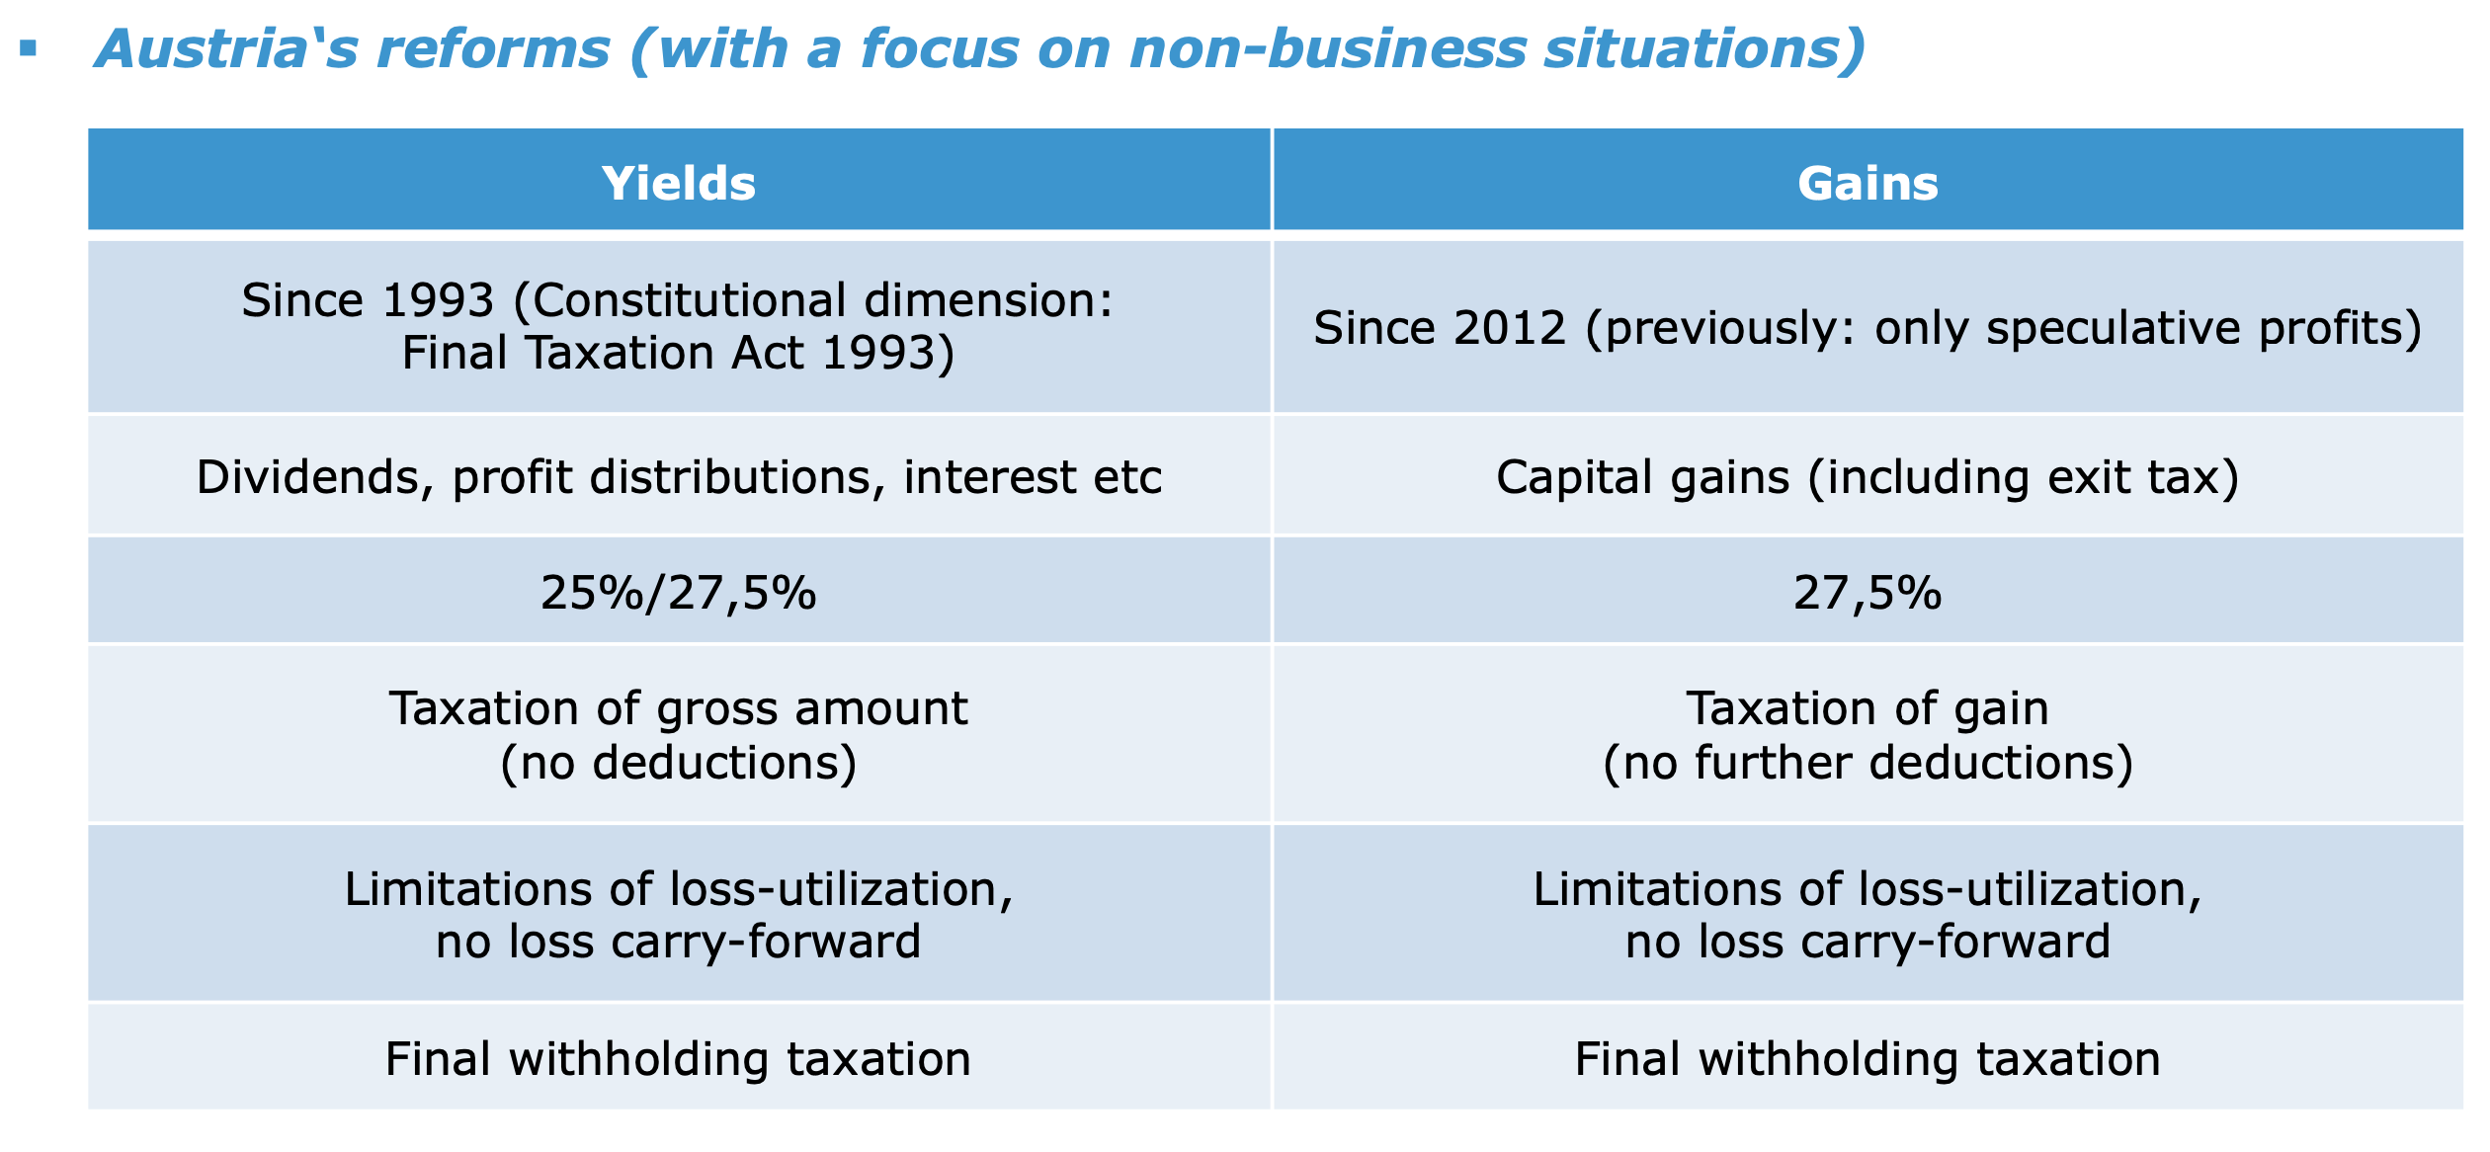
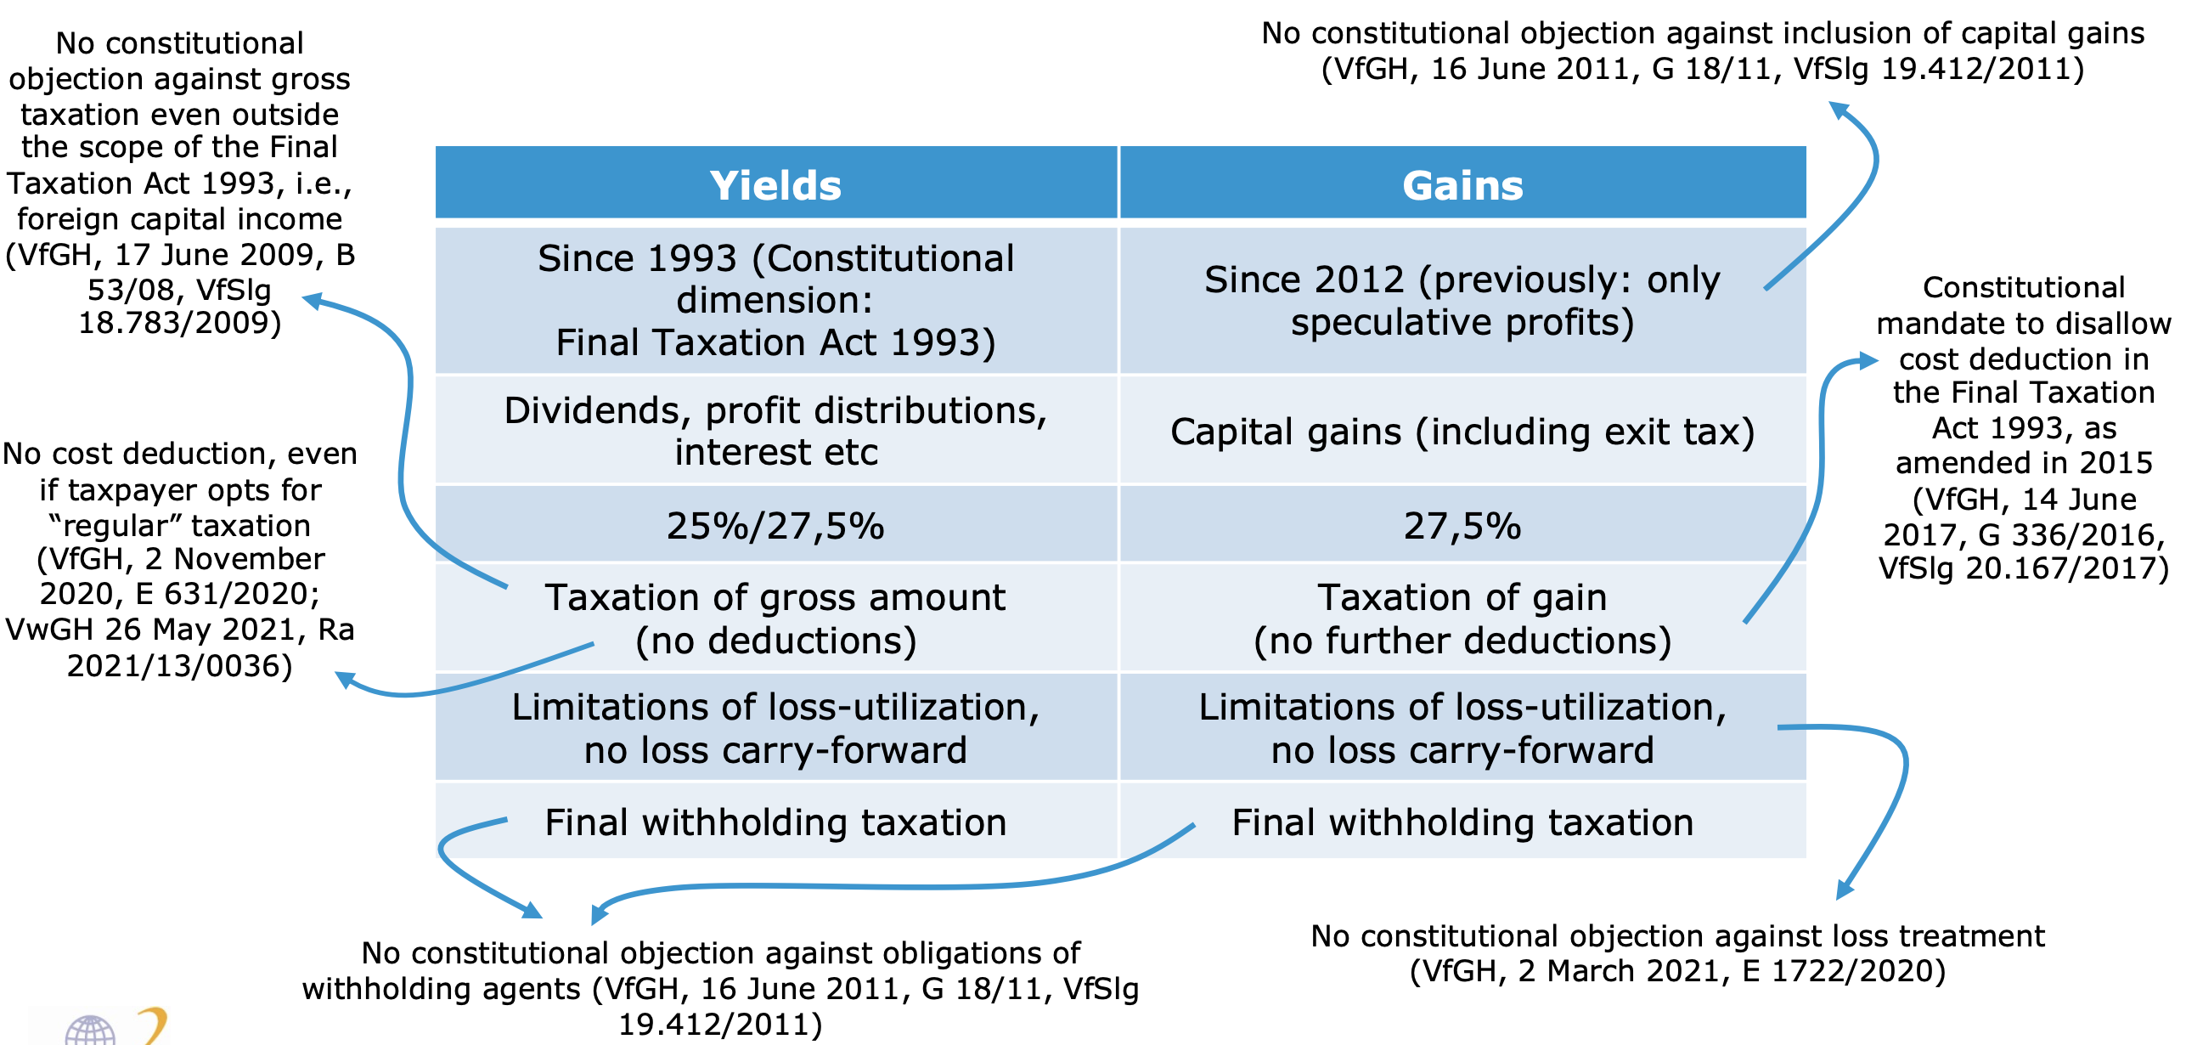

Alternative and substitutive regimes
N/A.

France

Individual Income Taxation
Presentation by
Prof. dr Andreas Kallergis, Pantheon-Sorbonne University of Paris I
andreas.kallergis@univ-paris1.fr

Structure
The French tax system includes a personal income tax, subject to different provisions than the corporate income tax.

Comprehensive vs. Schedular Approaches
One comprehensive personal income tax established on net income, derived on an annual basis (civil year), which is available to the taxpayer.
- No general definition of taxable income: income includes all net results of the taxpayer’s income categories (schedular approach)
- Categories: employment income / real estate income / portfolio income (optional inclusion) / capital gains from the transfer of securities (optional inclusion) / agricultural income / business income (bénéfices industriels et commerciaux) / other professional income (bénéfices non commerciaux = basket clause)
- The net result for each category of income is computed under each category’s own rules and then added-up to form the gross aggregate income.
- Personal deductions and allowances are then offset against gross aggregate income to find net aggregate income.

The comprehensive personal income tax coexists with:
- tax (PAYE) on employment income ( since Jan. 2019 - progressive)
- tax on capital yields (proportional since Jan. 2018 – 12,8% rate)
- tax on capital gains from immovable property transfer (proportional – 19% rate)
- tax on capital gains from transferable securities (proportional – unless the taxpayer chooses to include in the comprehensive income subject to the progressive tax scale)
- tax on capital gains from transfer of movable property (proportional)
- tax on investment income (unless the taxpayer chooses to include in the comprehensive income subject to the progressive tax scale)
- exit taxation
- withholding taxation on specific payments by a resident debtor to non-resident creditors

Withholding (PAYE) vs. declaration and assessment
Declaration and assessment: income filing duties burden all individuals that derive income subject to taxation through the assessment system.
- income filing liability is combined with pre-filled declarations for employment income. Tax is computed on the basis of the tax return and an assessment is sent to the taxpayer.
- Since 2020, pre-filled returns are deemed to be implicitly approved if the taxpayer does not send them back to the administration.
- The filing obligation remains in full for taxpayers of which data are incomplete or inaccurate.
- The income tax already paid is credited against the final tax.

Taxes withheld at source:
- employment income (since Jan. 2019), subject to the PAYE system (also: retirement pensions and replacement income)
- capital yield income (dividends, interest, capital gains, income from life insurance): non-final WHT - two-step approach: 1) withholding tax at the time of distribution and 2) tax credit offset against income tax liability – excess is refundable.
- royalties (also non-final WHT –credited against income tax liability)
- exception: final withholding tax is levied for some categories of income (life insurance and capitalization contracts (on option), fixed-return investment income paid to a non-cooperative State or territory or to unknown beneficiaries.

Taxation of gross vs. net income
- Employment income is taxed as net income under the PAYE system
- Capital yields flat-rate taxation applies to gross income, unless the taxpayer requests to introduce them to the progressive income tax scale, in which case they benefit from a 40% allowance. The option is expressed through tax return filing. The option is limited to French tax residents.
- Foreign-source portfolio income, director’s fees, professional income and remuneration received by artists and sportsmen are taxed in France on their gross amount, including foreign withholding taxes.
- Withholding taxation on income paid by a resident debtor to a non-resident applies on gross income.

Accrued income vs. unrealized income vs. imputed income
The personal income tax is due on income “accrued by or available to the taxpayer” (art 12 GTC). This broad definition entails that unrealized income taxation or notional income taxation are not to be qualified as exceptions.
Unrealized income: taxation applies on unrealized capital gains for taxpayers who become resident of another country and who hold substantial shares (= of a value exceeding 800,000 EUR, or that entitle the shareholder to receive at least 50% of the company’s profits) (rate: 12,8% unless option for the progressive system by the taxpayer). The tax paid is credited against effectively payable (if the shares are effectively transferred).
Refund is possible if shares are not transferred within 2 years (if value lower than 2,57M) or within 5 years (if value higher than 2,57M).
Exit tax does not apply if residence is transferred to an EU or EEA member State. It is also deferred when residence is transferred to a country that has concluded with France a double taxation agreement covering administrative assistance or has concluded a convention on mutual assistance with France and is not qualified as a non-cooperative jurisdiction.
Notional income: based on the taxpayer’s lifestyle, the tax authorities may, in limited cases and subject to certain restrictions, raise a notional assessment of the taxpayer’s income, if the income declared is substantially lower than the taxpayer’s lifestyle would suggest. The rule applies also in the absence of declaration.

Specific tax rates or surcharges on certain types of income
Social surcharges (taxes) apply to different kinds of income subject to personal income taxation: employment income, rental income, dividends, interest and capital gains are subject to 9,2% contribution sociale généralisée, 0,5% contribution au remboursement de la dette sociale. All these categories, except from employment income, are also subject to a 7,5% solidarity levy.
Pensions and similar income are subject to a lower contribution sociale généralisée rate of 8,3%, or even 6,6% and 3,8% for lower pensions.
Exceptional contribution on high income: taxpayers whose income exceeds certain amounts are subject to an exceptional contribution. The rate is 3% on the portion of annual income over 250,000 EUR (or 500,000 for couples) and 4% on the portion of annual income over EUR 500,000 (or 1,000,000 for couples).

Taxable unit
Scope of the taxable unit
The taxable unit is the tax family (foyer fiscal). Both spouses enjoy equal status and are jointly liable for income tax on both incomes and the income of their dependent children or other dependants. The spouses are jointly liable for the payment of the tax assessed on the total income of the family unit.
The tax unit may be made up of only one person where the taxpayer is single, divorced or widowed.
Separate assessment and taxation is possible in some cases: under-age children may be taxed separately upon request on their separate personal income (if any); unmarried persons living together are taxed separately, unless they are bound by a civil partner pact (Pacte Civil de Solidarité).

Filing duties & Assessment
The taxable unit’s tax liability includes income of the declaring taxpayer and of the spouse, for married taxpayers, or of the civil partner under a “civil solidarity pact” (contractual civil union, PACS) plus income of the children belonging to the same tax family or income of other dependants.
The taxpayer must file a general return which indicates the family unit’s overall income and states the amount of each type of income, and, for certain types of income, must file a specific return which is annexed to the general return. The tax authorities calculate the tax due based on the returns.
Certain items of gross income, such as salaries (for which withholding taxation is not final) are added to the declaration to form the adjusted taxable income. Deductions related with such income may apply in this stage.
Once the adjusted taxable income has been determined, the progressive tax is computed according to the “family coefficient” (quotient familial) rules. The size of the taxpayer’s family defines the number of shares the household is entitled to. The husband and wife count for one share each. The first two children count for half a share each. Each child thereafter counts for one share (see table infra). Thus, a married couple with three children is entitled to four shares.
The amount of taxable income is divided by the number of shares to determine the income per share, which is used to compute the amount of tax per share by applying the progressive tax schedule. The tax per share is multiplied by the number of shares to give the gross tax bill. Certain tax reductions or increases are subtracted or added to this gross tax bill.
Regular tax credits, such as those matching the withholding taxes which may have been levied on certain foreign-source income, are subtracted to arrive at the final tax bill.

The extent of the coefficient (= number of parts) available to the fiscal household vary as follows:

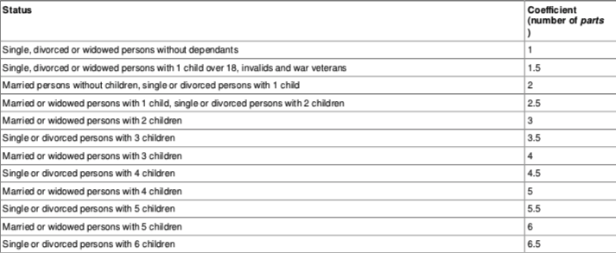

Tax deductions / allowances / reliefs / credits
Deductions
Deductions may apply to schedular income or to aggregate income.
The most important deduction on a schedular approach concerned employment income: a lump-sum 10% deduction is granted for salaries, related with deemed expenses in the accruance of income (maximum deductible amount in 2020: 12,652 EUR). If the taxpayer chooses to deduct actually suffered expenses, rather than the 10% lump sum, he bears the burden of proof for these expenses. The 10% notional deduction also applies to pensions.

The most important deductions that apply to the aggregate income include:
- - subject to certain conditions and ceilings, the taxpayer may deduct pensions paid to a former spouse and maintenance payments to children under a legal obligation or a court order (to be taxed on the level of the beneficiaries);
- - maintenance payments to children who have reached legal age and who are no longer part of the taxpayer’s tax family are deductible from the taxpayer’s income (up to 5,888 EUR per child);
- - subscribers to the popular pension savings plans (plans d'épargne retraite populaire) are entitled to a deduction for the premiums paid. The deduction is limited to (whichever is higher) (i) 10% of the income earned during the previous year, up to 8 times of the average annual social security ceiling for that year, or (ii) 10% of the annual social security ceiling.

Contribution sociale généralisée: CSG having burdened income subject to the progressive tax scale is partially deductible (2,4% remains non-deductible). CSG having burdened flat-rate taxed income is not deductible at all.
Contribution pour le remboursement de la dette sociale: non-deductible.
Solidarity levy on passive income: non-deductible.

Allowances
Taxpayers who are invalid or over 65 and whose net taxable income earned does not exceed 15,340 EUR (in 2020) may deduct 2,446 EUR from that income. The deduction is limited to 1,224 EUR if the total net income is between 15,340 EUR and 24,960 EUR. The deduction is double if both spouses qualify as invalid or persons over 65.
The parents of a person under 21 years (25 years if student) who is married or handicapped may declare their child (together with the child’s partner, if any) as a member of their household for income tax purposes. In such a case, the parents do not benefit from a higher coefficient, but are entitled to an allowance of 5,959 EUR (in 2020) for each person taken into account.

Credits
Income tax computed on the aggregate income may be reduced by credits (maximum in 2020: 10,000 EUR). Credits include:
- Principal residence expenses related with energy-saving equipment (up to 2,400 or 4,800 EUR for couples), plus 120 EUR per child – amount is fixed on a lump-sum basis depending on the equipment
- Donations to approved public or private non-profit organizations, including political parties, give right to a 66% tax credit (limit: no higher than 20% of taxable income – carry forward for 5 years is possible for the excess credit).
- Investments in new residential premises for rental purposes: if the aim of the investment in new residential premises is to rent out, tax reduction for a period of 6 or 9 years of 12% or 18% respectively of the amount of investment (for investments from 2013 to 2021)
- Subscription to shares in qualifying small and medium enterprises located in an EEA in their start-up period (5 years) allows the taxpayer to receive a tax credit of 18% of the amount of the investment (annual limit of 12,000 or 24,000 for couples). Excess credit may be carried forward in the next 4 years.

Losses
Income and expenses are assessed in each category of income (see supra 1). If a loss cannot be set off against a specific category, it can be set off against the aggregate income. However, losses from property investment, agricultural activities, non-commercial non-professional activities and professional business activities in which the taxpayer plays no active role may only be set off against income from the same category.
If the aggregate income also shows a loss, the loss may be carried forwarded for up to 6 years and set off against future positive income.
Specific rules apply for capital losses.

Additional tax relief
Taxpayers whose tax in 2021 is less than 1,720 EUR for single persons (2,847 EUR for couples) may credit against the computed tax the difference between 779 EUR (EUR 1,289, respectively) and 45.25% of the computed tax. This mechanism is known as the “décote”.
Example: A single taxpayer has a taxable income of EUR 25,000. The computed tax is 1,641 EUR. The additional tax relief is 779 – (1,641 × 45.25%) = 36 EUR. The final tax is therefore 1,641 – 36 = 1,605 EUR.

Tax residence / domicile
Criteria qualifying a tax domicile in France include:
- the presence of a home, or, in absence of any home, principal abode in France (personal / real test);
- the performance of employment or independent services in France, unless this activity is only auxiliary (substantial test);
- the presence of the centre of one’s economic interests in France (economic test);
- since 2019, chief executives and directors of French companies of which the annual turnover is higher than 250 M EUR, unless they prove that they do not carry out their main activity in France (rebuttable presumption of domicile)
- citizenship does not play any role for the qualification of residence under domestic law, apart from one case: French nationals living in Monaco are deemed to be French residents unless they are born and have always lived in Monaco or have been resident in Monaco for longer than 5 years by 13 October 1962.

Tax residence and tax family: tax domicile is assessed separately for each member of a tax household. Therefore, it is possible that spouses that form a tax household are resident and non-resident respectively have different filing obligations from a PIT perspective.

Extent of tax liability of resident / non-resident taxpayers

Resident taxpayers
Subject to treaty provisions, a resident individual is subject to tax on his worldwide income and capital gains (art. 4A GTC). Generally foreign income is subject to the same income taxes as domestic income.
Foreign income
- Employment income earned by a resident is generally taxable in France wherever the work is performed.
- Income derived by a resident from immovable property located abroad is taxed under the normal domestic rules. Tax treaties usually provide that such income is exclusively taxed in the country where the property is situated. Nevertheless, even if the income is exempt, it is taken into account in determining the effective income tax rate on the taxpayer’s other income (exemption with progression method). Most recent treaties adopt the credit method rather than the exemption method.
- Foreign-source dividends, interest and royalties received by a resident are taxable in France on their net amounts. However, where a tax treaty provides for a tax credit, the recipient is taxed on the income as grossed up by any foreign withholding tax, and a credit is available for that tax.
- Foreign-source dividends and interest are generally fully included in taxable income subject to individual income tax at the flat rate of 12.8% (plus social taxes). However, where the taxpayer opts to subject dividends to income tax at progressive rates, only 60% of the net amount of dividends received from EEA countries or DTC countries are taxed.
Capital gains
- Capital gains derived by a resident from immovable property located abroad are taxed under the normal domestic rules. DTC may provide that capital gains are exclusively taxable in the country where the property is situated. In this case, foreign capital gains are not taxed in France but they must generally be taken into account to determine the effective tax rate applicable to other types of income (exemption with progression method).
- Subject to tax treaty provisions, capital gains on foreign securities are subject to tax at the same rates and under the same rules as capital gains on French securities. However, capital gains from the sale of shares held in companies located in non-cooperative jurisdictions do not benefit from the long-term gains regime, unless the taxpayer proves that the participation neither aims at, nor results in, the abusive shifting of profits in this.

Non-resident taxpayers
- Tax base: non-residents are subject to French income tax for French-source income = income derived from rights, assets or activities located in France or to income paid by a French resident. Statutory provisions provide for income for which source taxation applies.
- Tax rate: non-residents are normally subject to the same rates as residents for the same category of income. However, the law establishes minimum rates for income taxation for non-resident taxpayers. Therefore, for 2020, non-resident that derived income lower than 25,710 EUR is subject to a minimum tax rate of 20%, while French-source income higher than 25,710 EUR is subject to a minimum 30% tax rate.
Non-residents can claim that, should they be resident in France, their overall taxation of worldwide income would have been lower than the minimum one, and therefore obtain a tax reduction.
- Practically most rules of the computation of resident income, such as the family coefficient and the expenses computation, also apply to non-residents.

Employment income paid to non-residents, including pensions, are subject to withholding taxes at progressive rates. The tax base for the withholding liability is the annual salary after deduction of social security contributions and the 10% income tax notional expense deduction.
Investment income paid to non-residents: dividends: final 12,8% withholding tax; interest: no WHT (unless paid to a non-cooperative jurisdiction: 75% WHT, but rebuttable presumption of tax avoidance); royalties: non-final WHT on the gross amount of royalties if the non-resident does not have a fixed base in France (75% if payment to non-cooperative jurisdiction).
Income from immovable and movable property: same for residents.
Capital gains realized by non-residents: 19% flat rate of tax for sale of immovable property located in France (+17,2% social taxes OR 7,5% if the taxpayer is affiliated with a mandatory social security scheme in another EU MS).
Exception: tax exemption for the sale of share in French companies, unless the sale concerns substantial ownership in a resident company (direct or indirect ownership of at least 25% of the rights to the company’s profits), in which case: final 12,8% WHT (or 75% if capital gain realized by a non-cooperative jurisdiction resident).

Rates
Comprehensive Personal Income Tax

Personal Income Tax is charged at progressive rates.

Tax rate band | 2021 assessment
0% | up to 10,084
11% | 10,084-25,710
30% | 25,710-73,516
41% | 73,516-158,122
45% | over 158,122

The gross aggregate income is determined by adding up the net results of all categories of income. The net aggregate income is determined by applying the personal deductions and allowances. The net aggregate income is then divided by a family coefficient (see supra 2) to obtain the net taxable income per part. The tax table rate is applied to the result in this step; the tax so computed is then multiplied by the same coefficient to obtain the gross tax burden. This lengthy procedure can be usefully replaced by the use of a computation formula (see infra).

Example: For a net taxable income of EUR 100,000 and a family coefficient of 4 (e.g. two parents and three children), the income is divided by four to obtain a taxable income per part of EUR 25,000. The tax table rate is applied to determine the tax on EUR 25,000 (EUR 1,640.76 in 2020) and the result is multiplied by four to obtain the aggregate gross tax (EUR 6,563.74 in 2020). The same result is reached much faster by using the computation formula.

Alternative computation formula:
A simplified method allows to find the gross income tax, taking into account the net taxable income (I) and the number of part (C) according to the coefficient system (2020 income brackets):
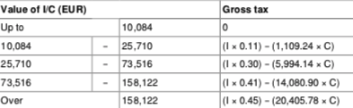

Once the gross tax liability is assessed, adjustments are to be made to find the net tax liability. Adjustments include the use of tax credits of the current year or carried over (see supra 2), foreign tax credits and already paid non-final WHT.

Limitations to the coefficient system
The family coefficient system results in an effective limitation of the progression of the income tax. To reduce this effect, the tax benefit resulting from having children is limited to certain amounts. The reduction of income tax resulting from the application of the family coefficient may not exceed:
- for every half part exceeding the initial part (single, divorced or widowed) or the initial two parts (married) corresponding to the parent(s), the tax benefit may not exceed 1570 EUR;
- for every quarter part in excess, the tax benefit may not exceed 785 EUR; and
- for single, divorced or separated persons with a dependent child, the benefit is limited to 3,704 EUR for the first additional two half parts corresponding to the child.

Where the limitation applies, a theoretical income tax is computed using the initial number of parts. The amount so obtained is reduced by the amounts mentioned above (in general 1570 EUR per half part). The theoretical income tax less the maximum coefficient benefit results in the income tax after the coefficient benefit limitation. The income tax liability of the taxpayer cannot be less than the income tax after the coefficient benefit limitation.

Dividends and interest
Subject to a 12,8% flat-rate tax (prélèvement forfaitaire unique since 2018) applicable to the gross amount (+ social taxes, total 17,2% added on 12,8%). Option for submission to the ordinary progressive tax rate possible. In such case: 40% allowance is possible (60% of the dividend is taxed). The option is exercised through the tax returned filed in the year following the one when the dividends were received. The option is irrevocable and concerns all investment income of the taxpayer (dividends, interest, royalties).
For resident taxpayers, the withholding tax is non-final and can be credited against the final income tax liability or refunded if in excess.
Taxpayers with an annual taxable income of 25,000 EUR (or 50,000 for couples) may request exemption from the 12,8% withholding tax.
Exception: interest from life insurance contracts, fixed-return investment income paid to non-cooperative jurisdictions or to unknown beneficiaries are subject to a final WHT.
Exception: The following types of interest are exempt from income tax and social taxes: interest from savings accounts (livret A), maximum deposits of 22.950 EUR, remunerated at 0,5% annual rate); other kinds of savings plans, of which the use is restricted to low-income taxpayers or to young taxpayers, are also tax-exempt.

Royalties
Subject to a 10% WHT (+ 17,2% social taxes = 27,2% total tax burden) when they concern patents, patentable inventions and qualifying production processes accessory thereto. Option for submission to the progressive tax scale possible, like in the dividend/interest case. Royalties related with trademark or copyright are subject to the progressive tax scale (+ social taxes).

Income from capital
The French tax system both includes taxation of capital gains and taxation of capital yields.
For the taxation of capital yields, see supra 3 (Rate), regarding the taxation of dividends and interest.

With regard to capital gains:

Immovable property
Capital gains on immovable property or rights thereon, e.g. participations in real estate partnerships, whose assets consist for more than 50% of immovable property, are subject to tax at a flat rate of 19% (increased to 36.2% by the 17.2% overall social taxes).
Exception: capital gains on the transfer of the taxpayer’s principal residence are exempt from the above tax and additional social taxes. Gains on any immovable property are also exempt if the sales price does not exceed 15,000 EUR.
Mitigated tax liability: annual reductions apply to the taxable basis of capital gains from the alienation of real estate. The reduction of the capital gain subject to the flat-rate tax amounts to: 6% for each year of ownership beyond the 5th year until the 21st year; and 4% for the 22nd year of ownership. The capital gain is thus totally exempt from the flat-rate tax after 22 years.
The reduction of the capital gain subject to the social taxes amounts to: 1.65% for each year of ownership beyond the 5th year until the 21st year; 1.6% for the 22nd year of ownership; and 9% for each year after the 22nd year. The capital gain is thus totally exempt from social taxes after 30 years of ownership.

Shares
From 1 Jan. 2018, capital gains are subject to income tax at the flat rate of 12.8% (prélèvement forfaitaire unique, PFU). Taxpayers may opt to be subject to income tax at progressive rates. The election for taxation at progressive rates is made in the income tax return filed in the year following the one when the capital gains were derived. It is irrevocable and applies to all investment income received by the taxpayer.
Special regime: capital gains realized between 1 Jan. 2018 and 31 Dec. 2022 from the sale of shares in small and medium-sized enterprises by their director/owners at the moment of their retirement may benefit from a lump-sum base reduction of 500,000 EUR, if the shares were held for at least one year.
Capital gains from the sale of shares, bonds and similar securities are also subject to social taxes at a total rate of 17.2%. In case capital gains are subject to the flat tax at the rate of 12.8%, the overall taxation rate is 30%.
Specific regimes: Subject to a number of conditions, in order to promote company restructuring, rollover relief is available for gains realized upon a merger, division or exchange of shares. As an exception, when capital gains are realized in the context of habitual sales of shares, income is taxed in the professional income category of the personal income tax.

Business assets
Capital gains from the disposal of business assets by an individual may be taxed in two ways, depending on whether they are short-term or long-term gains.
Tax base: the tax is levied on the sales price less the acquisition cost. Any recaptured depreciation is taxed as ordinary business income.
Short-term gains= gains from the disposal of assets held for less than 2 years, are taxed as business income. An option to spread the gains over 3 years is available.
Long-term gains= gains from the disposal of assets held for at least 2 years, are subject to tax at a flat rate of 12.8%, increased to 30% by the 17.2% social taxes.
Exemptions: long-term gains are exempt if the taxpayer’s turnover does not exceed a certain ceiling and the activity is exercised for at least 5 years.
SMEs are exempt from tax on capital gains derived from the disposal of business assets if their annual turnover does not exceed 90,000 EUR (for suppliers of services) or 250,000 EUR (for suppliers of goods). A partial exemption applies if the annual turnover does not exceed 126,000 EUR (for suppliers of services) or 350,000 EUR (for suppliers of goods).

Cross-border capital gains taxation issues
1 - Capital gains of French residents realized abroad: capital gains derived by a resident from immovable property located abroad are taxed under the normal domestic rules. Tax treaties may provide that such capital gains are exclusively taxable in the country where the property is situated. In this case, foreign capital gains are not taxed in France but they must generally be taken into account to determine the effective tax rate applicable to other types of income (exemption with progression method).
Subject to tax treaty provisions, capital gains on foreign securities are subject to tax at the same rates and under the same rules as capital gains on French securities. However, capital gains from the sale of shares held in companies located in non-cooperative jurisdictions do not benefit from the long-term gains regime, unless the taxpayer proves that the participation neither aims at, nor results in, the abusive shifting of profits in this jurisdiction.
2 - Capital gains of non-residents realized in France: subject to tax treaty provisions, capital gains realized by non-resident individuals from the sale of immovable property located in France (or from the sale of shares in unquoted entities whose assets consist of immovable property for 50% or more) are subject to flat-rate 19% income tax, regardless of the State of residence of the seller.
Moreover, such capital gains are subject to the 17.2% social taxes, reduced to 7.5% for taxpayers affiliated with a mandatory social security schemes in another EU MS. Non-residents may benefit from the allowances and exemptions applicable to residents, with some exceptions.
Exception: capital gains realized by non-residents from the sale of shares in French companies are generally exempt. However, capital gains derived by a non-resident individual from the sale of shares in a substantially owned resident company (=where the shareholder directly or indirectly holds or has held at any time during the preceding 5-year period 25% or more of the rights in the company's profits) are subject to a 12.8% final withholding tax (rate since 1 Jan. 2018). The rate is increased to 75% if the capital gain is realized by a resident of a non-cooperative jurisdiction, regardless of the level of participation.

Alternative and substitutive regimes
No general alternative or substitute regime exists. However, there is a special treatment available on option for exceptional or deferred income.
Exceptional and deferred income taxation: to mitigate the progression of the personal income tax, a spreading option is allowed with respect to exceptional non-recurring income (e.g. liquidation distribution from a company) which exceeds the taxpayer’s average taxable income of the preceding 3 years. Exceptional income is qualified both through its nature and through its amount.
The spreading applies as follows: 25% of the exceptional income is added to the taxpayer’s ordinary taxable income of the relevant year; the surplus income tax corresponding to this 25% of exceptional income is multiplied by four to arrive at the total income tax on the exceptional income.
The spreading option applies also to deferred income, i.e. income which is normally paid periodically but for reasons beyond the taxpayer’s control is paid in 1 year (e.g. income blocked abroad), irrespective of its amount. No amount-related condition is set to benefit from the spreading option on deferred income.
In both cases, the exceptional or deferred income is subject to the progressive tax scale.

Germany

Individual Income Taxation
Presentation by
Prof. Dr. Ekkehart Reimer
Universität Heidelberg, Institut für Finanz- und Steuerrecht
https://www.jura.uni-heidelberg.de/fst/
reimer@uni-heidelberg.de

Structure
The Einkommensteuer (Individual Income Tax – ESt, laid down in the 1925 Einkommensteuergesetz – EStG, as amended) is a formally comprehensive income tax, which is composed of seven categories of income (income from agriculture and forestry, business income, income from independent personal services, employment income, capital yieds and financial capital gains, rental income, other income).

It is not a catch-all tax, however. Most notably, long-term capital gains from the sale of private immovable property (be it used as taxpayer’s dwelling, be it rented out to third persons or left unused) are not taxable.

In turn, other capital gains are taxable, but subject to a certain lump-sum reduction with a view to a future burden of the gift & inheritance tax (sec. 35b EStG). Similarly, the ESt covers certain non-realized capital gains upon emigration (exit tax, laid down in sec. 6 Außensteuergesetz) or upon transfer of assets to an exemption country (PE cases, cases of dual residence: sec. 4(3) EStG).

Within the structure of the comprehensive ESt, any earning-related expenses are deductible on quite generous terms. This is also true for employees (e.g., deductions for trip from home to the place of work; see secs. 4 et seq., 9 et seq. EStG). Yet, private capital yields as well as private financial capital gains are subject to a special regime (infra 4.).

Taxable unit
The ESt is a tax upon individuals. There is no family taxation sensu strico, but spouses can apply for joint assessment and equalization of their income (Ehegattensplitting) so that their (joint) burden is not affected by symmetrical or asymmetrical distribution of income between the two (secs. 26 et seq. EStG).

Neither partnerships nor bodies corporate are subject to the ESt themselves. Yet, partnerships are assessed, with their profits being attributed (imputed) to each single partner pro rata (transparency), irrespective of whether or not actual payments have been made.

While resident individuals are taxable on the basis of their world-wide income, non-residents are subject to a territorial regime (sec. 49 EStG). For passive income, non-resident non-EU/EEA individuals are not allowed to deduct expenses in most cases (see sec. 50 EStG for details).

Rates
Apart from the encapsulated 25 per cent flat tax for private capital yields and financial capital gains (supra 1.), the ESt follows a progressive scheme. All taxpayers (even high-income earners) obtain a 9,744 Euro basic free amount for themselves (doubled for spouses in case of joint assessment; supra 2.) plus 8,388 Euro per child.

All items of income above these free amounts are taxed at a specific rate for each extra Euro (system of marginal rates), starting at 14 per cent (first Euro beyond the threshold), but rising quite steeply up to a marginal rate of 24.1 per cent for Euro no. 14,700, then rising more moderately up to 42 per cent for Euro no. 57,900. A final step from 42 to 45 per cent applies to all Euros beyond 275,000 Euro (Reichensteuer). Evidently, the average rates are much lower. If a couple (no children) earns a joint net income of 100,000 Euro, they pay less than 25 per cent income tax.

Income from capital
Private capital yields (sec. 20(1) EStG) as well as private financial capital gains (sec. 20(2) EStG) are subject to a special regime, viz. a 25 per cent lump-sum taxation on a gross basis (Kapitalertragsteuer, secs. 32d, 43 et seq. EStG), irrespective of whether the payments constituted deductible expenses on the side of the payor (e.g., interest) or not (e.g., dividends).

There is no inflation adjustment, not even for long-term financial capital gains.

For resident individual, and unless a DTC provides otherwise, any foreign tax on those items of income is credited against the German Kapitalertragsteuer.

Alternative and substitutive regimes
Germany levies a solidarity surcharge on high-income earners, amounting to 5.5 per cent of their Einkommensteuer.

Members of a church (if established under public law) pay 8 or 9 per cent church tax, levied by the State but (minus an administrative compensation) transferred on to the respective church or religious community.

Business income (other than income from agriculture, forestry or independent personal services) is subject to the local business tax (Gewerbesteuer) at a level fixed by the local municipality. For most municipalities, the tax rate remains in a bandwidth between 12 and 18 per cent). Up to a tax rate of 14 per cent, the Gewerbesteuer is creditable against the Einkommensteuer. This mechanisms avoids or mitigates the problem of a double burden.

Spain

Individual Income Taxation
Presentation by
Prof. dr F. Alfredo García Prats, Universitat de València
alfredo.garcia@uv.es

Structure
-IRPF is a formally comprehensive income tax, which is composed of six categories of income (income from work, income from capital, business income, capital gains and losses, imputed income, and income from fiscal transparency).

-Despite of being a comprehensive income tax, income is divided between general income and savings income.

-Capital gains subject to Gift and Inheritance Tax are not subject to IRPF (individual income tax).

-Capital gains are generally calculated as the difference between the transmission and the acquisition values. Normally, only realized and accrued gains are subject to taxation, unless some exceptions or exit taxation on hidden capital gains applies.

-Other income will be determined as the difference between the gross income less deductible expenses. Only as regards immovable rented income and business taxation necessary expenses are generally deductible, unless the profit is calculated according to a simplified regime. For other income, only specific limited accepted expenses can be deductible.

-5 different regulations (State IRPF+ foral IRPF= Navarre, Álava, Vizcaya, Guipúzcoa).

-IRPF is a State tax but it is partially yielded to regions (non-foral CCAA) as of 50% of the tax quote, with the possibility of CCAA to introduce specific tax rates and tax deductions on the portion of the tax quote being yielded with some limitations.

-Many categories of income are subject to PAYE mechanisms (withholding tax, on account payments and payment in instalments; income from work capital income and business income). As a result, most taxpayers do not have to fill in self-assessments, which remain mandatory in many cases though.

Taxable unit
-Since 1990 IRPF is an individual tax. Each individual is the taxpayer as a general rule. However, members of the family unit may present a single self-assessment putting all individual income in one assessment. In that case all members are severally liable for the whole payment. Similar tax rates apply in that case. No quotient, no splitting.

-Liability and assessment of the taxable unit’s income is made optionally by joining all individual income.

-Income is ‘individualized’ according to specific tax criteria (carrying on the activity, or asset ownership, basically), regardless of the civil law determining ownership of the income.

-Taxable units do not have, as a general rule, additional benefits. Family benefits are applied on a personal basis. Joint assessment by taxable units derives in several liability.

-Residence status is applied based on 3 criteria: length of stay (183 days a year), main economic basis or interest in Spain, and presumption of residence by residence of members of taxable unit.

-Resident taxpayers subject to IRPF are taxed on a worldwide basis. Some income from work carried abroad can be exempted. Other foreign income is subject to domestic or tax treaty credit.

-There are rules for fixing Regional tax residence of individuals (days of stay, habitual abode, main centre of interest, last residence declared). Specific tax rates, tax reductions and tax credits.

-Non-resident taxpayers are subject to Non-residents Income Tax (IRNR), both individuals and entities on a territorial basis.

Rates
-Generally, Spain applies two tax rates to individual income, plus a specific tax rate to lottery prizes (20% above 2500 euros).

General income (6 brackets)
Taxable base  –  Up to euros | Tax amount  –  euros | Rest of taxable base  –  Up to euros | Tax rate  –  Percentage (in total, State rules)
0,00 | 0,00 | 12.450,00 | 19
12.450,00 | 2.365 | 7.750,00 | 24
20.200,00 | 4.225,5 | 15.000,00 | 30
35.200,00 | 8.725,5 | 24.800,00 | 37
60.000,00 | 19.901,5 | 240.000,00 | 45
300.000,00 | 125.901,5 | En adelante | 49

General income
General State tax rate+ regional tax rate 2021 | Minimum rate | Maximum rate
Andalucía | 19,00 % | 48,20 %
Aragón | 19,50 % | 50,00 %
Canarias | 18,50 % | 50,50 %
Cantabria | 19,00% | 50,00 %
Castilla La Mancha | 19,00 % | 47,00 %
Castilla y León | 19,00 % | 46,00 %
Cataluña | 21,50 % | 50,00 %
Madrid | 18,50 % | 46,50 %
Valencia | 19,50 % | 54,00 %
Extremadura | 19,00 % | 49,50 %
Galicia | 19,00 % | 47,00 %
Islas Baleares | 19,00 % | 49,50 %
La Rioja | 18,50 % | 51,50 %
Principado de Asturias | 19,50 % | 50,00 %
Región de Murcia | 19,00 % | 47,00 %
Navarra | 13 % | 52,00 %
Bizkaia | 23,00 % | 49,00 %
Álava | 23,00 % | 49,00 %
Gipuzkoa | 23,00 % | 49,00 %

Savings tax rates (2021)
Taxable (savings) base in Euros | Tax rate
6000 | 19
From 6000 on | 21
From 50.000 on | 23
From 200.000 on | 26

-Total personal income tax quota plus net wealth individual tax quota per year cannot exceed 60% of total personal tax base.

-There are deductible amounts from the general tax base before the application of the tax rate (joint taxation, pension schemes contributions, disability pension schemes contributions, compensatory pensions and child maintenance annuities, among others.

-Personal and family minimum
-Per taxpayer (personal minimum) 5.500 euros.
-Per descendants <25 living together: 2400 (1st), 2700 (2nd), 4000 (3rd), 4500 (4th and ff). Minors of 3: 2.800 additional.
-Per ascendants living together with lower income (<8000): 1150 (>65), 1400 (>75).
-Per disability: 3000/9000 (>65%disability).

-There is no specific mechanism for updating the amounts of the personal and family minimum unless a legal change occurs. They have not been updated since November 2014.

-There are both State tax credits and Regional tax credits (only applicable to 50% of the tax quota). State tax credits refer to business investments, donations to non-profit organizations, protection of National and World Heritage, home improvement expenses). Regional tax credits are mainly of personal and social character (family protection, depopulation, etc.), not of business character and have a very limited impact.

-There is no mechanism in individual income tax to alleviate economic double taxation.

Income from capital
-Taxable base is divided between general income and savings income.

-Savings income is made of net positive movable capital income (except interest from related parties), capital gains from transfer of assets, regardless of the generating period.

-General income is made of income from work, business income, capital gains and capital income not included in savings income (immovable capital income) and imputations of income from urban property.

-General income is subject to the general progressive tax scale (state + region tax scales). Income from work cannot ever be negative. Business income can be negative unless the simplified regime applies.

-There are several restrictions for compensation between gains and losses and for inclusion of losses in the taxable base. Yields can be compensated among them without limitation. Only positive net amount of capital gains (and losses) which do not derive from a transfer of assets can be incorporated in the taxable base. Negative amount can be compensated with positive net amount of future years up to 25% during the 4 years ahead. The same rule applies for capital gains included in the savings income tax base.

-Necessary expenses are deductible from immovable capital income and from business income (except simplified regime). Other income (capital movable income) have very limited deductible expenses. Income from work use lump-sum systems of deductible systems, depending on the amount of gross income. Inflation effects are not considered when calculating the amount of capital gain or loss.

-Business assets contribute to the generation of business income -can be depreciated- and (private) non-business assets generate capital income or imputed income -can be depreciated only if immovables are rented-. Transfer of business and non-business assets are all treated as capital gains.

-There are specific rules that determine the obligation to present a self-statement. Application of PAYE systems (payments on account, withholding taxes) are not necessarily final. Claim of excess withholding taxes requires mandatorily a self-assessment.

-According to Spanish Constitutional Court the Spanish dual income tax is not contrary to the ability to pay principle or to the equality principle.

Alternative and substitutive regimes
-Spain does not have as a general rule an alternative regime for individual income tax.

-However, inpatriates may opt to apply the application of the Non-residents Income Tax (IRNR) during the year of arrival + 5 additional tax periods only on Spanish territorial income. Worldwide income from work is subject to tax though.

-Income is subject to 24% and excess of 60.000 euros subject to 45%.

-Only applicable if inpatriates have not been resident in Spain in the last 10 days. Not applicable to professional sportspersons.

UK

Individual Income Taxation
Presentation by
Dr Leopoldo Parada, University of Leeds School of Law
l.parada@leeds.ac.uk

Structure
- The UK PIT system includes basically:

- PAYE (pay as you earn) for employment income – withholding tax
- Self-assessment system (SA) ––personal business income
- Capital gain tax (CGT)

- Personal allowance of 12,570 GBP for the year 2021/22 (per individual), subject to adjustments for annual income over 100,00 GBP, and no allowance over 125,140 GBP
- Marriage allowance: 10% of personal allowance from one partner to the other (married or civil partnership).
- Deduction of business expenses (“wholly or exclusively”)
- The taxable year in the UK goes from 6 April until the 5 of April of the following year.

Taxable unit
- The United Kingdom has an individual filing unit with a limited deduction that provides relief to married couples (see above, “marriage allowance”).
- Individual-residents or domiciled in the UK are subject to taxation on worldwide income. Non-residents/non-domicile are subject to taxation in the UK only on income sourced in the UK, other than in respect of UK property/'property-rich' companies or carried interest, even if the asset is located in the UK, which are subject to a capital gain tax (CGT).

Rates
Personal Income Tax is charged at progressive rates:
Tax rate band | Income 2021/22 GBP
20% | 0-37700
40% | 37701-150000
45% | Over 150000

There is a rate of 0% for “saving income” (e.g., interest) only up to 5,000 GBP. However, it only applies if there is saving income. Otherwise, the first bracket is 20%.

The rates for dividend income are different and are calculated depending on whether the individual’s band for PIT (see below). There is also a “dividend allowance”, which means that up to 2,000 GBP are taxed at a 0% rate (the amount of dividends still counts for determining the general brackets of PIT).

Tax rate band
7.5%
32.5%
38.1%

Example: An individual has dividends for 3000 GBP and wages for 29,570 GBP. The total income is, therefore, 32,570 GBP. Taking off the personal allowance of 12,570 GBP, the taxable income is 20000 GBP. Therefore, 17000 GBP are taxed in the band of 20% PIT; 2000 GBP (dividends) are not taxed and 1000 GBP (dividends) are taxed at a rate of 7.5%.

Income from capital
- Capital gains up to 12,300 GBP are not taxable. After this, if the amount falls within the basic tax band (37,500 GBP), the rate applicable is 10%. Anything over this amount is taxed at a rate of 20%.
- UK residential property is taxed at a different rate: 18% (if the amount falls within the basic band of PIT) and 28%.
- Example: an individual with a taxable income of 20,000 GBP has capital gains for 12,600 GBP. An amount of 12,300 GBP is not taxable. The remaining 300 GBP is added to the 20,000 taxable income to determine whether the individual’s applicable rate. In this case, 20,300 GBP is below 37,500 GBP, so the rate is 10%.
- Gains and losses are calculated by reference to the cost of the asset plus allowable costs of subsequent improvements.
- Deductions in computing a gain or loss will include the cost of acquisition (including the purchase price, incidental costs of purchase, and any capital enhancements) and incidental costs of disposal (including legal fees, costs of advertising, etc).
- From April 2020, UK residents must report and pay the CGT due 30 days after completion in respect of UK residential property disposed of which results in a chargeable gain.
- Non-UK residents are not subject to CGT (even on UK property), unless it is gain derived from UK trading assets.
- Different rules for “non-wasting chattels” (non-wasting= useful life over 50 years)/chattel= tangible movable property). If the disposal was for an amount below 6,000 GBP, no CGT. Over that amount, special rules apply.

Alternative and substitutive regimes
The remittance basis of taxation

- Elective system for non-domicile/resident individuals in the UK.

- Individuals can elect to pay tax on overseas investment income, capital gains, and certain offshore earnings only to the extent that these are remitted to the UK. Therefore, overseas income and gain no remitted to the UK are not subject to tax in the UK.

- Individuals eligible are in three categories:
- Residents/ not domiciled in the UK who pay (if necessary) the remittance basis charge (RBC) annual payment. A claim is required in order to benefit from the remittance basis.
- Non-UK domiciled individuals who have unremitted non-UK income and gains on non-UK assets that are less than GBP 2,000 in the year. The remittance basis applies automatically and no claim is required.
- Non-UK domiciled individuals who have been UK resident for less than 7 out of the preceding 9 years, or are under 18 years of age, and who have no UK sources of income and gains and do not remit any foreign income or gains. The remittance basis applies automatically.
- Individuals who are resident in the UK more than 15 years cannot opt for the remittance basis taxation.
- An individual electing the remittance basis is not allowed to use the personal allowance of 12,570 GBP.
- An individual who wishes to claim the remittance basis of taxation but has been resident in the United Kingdom in at least 7 out of the previous 9 years and is over 18 years of age will have to pay an additional tax charge of GBP 30,000 each tax year to enable them to use the remittance basis of taxation (remittance basis charge––RBC). The RBC goes up to 60,000 GBP for those non-domiciled individuals who have been resident in the United Kingdom for 12 out of the past 14 years.
- The RBC is a tax on either income or capital (depending on the non-remitted funds), and as such it should be creditable. The IRS, for example, has formally granted a credit to US citizens claiming a credit for the amount of RBC paid in the UK. However, this seems to be a case-by-case analysis.

